**NANYANG TECHNOLOGICAL UNIVERSITY**

**2nd YEAR COMPUTER ENGINEERING**

**Circuits and Signal Analysis - CE2004**



Lab 4

 Signals

Name:

Group:

Date:

Table of Contents

**No table of contents entries found.**

# Introduction

In this lab, MATHLAB R2015 software will be use to demonstrate how signal like Step, Rectangular, Ramp and delta can be generated. The last part of the lab is to familiarize us with the Laplace transform as well as simulating it with MATHLAB R2015 the behavior of Laplace transform itself.

# 5.1 Defining and plotting step functions

Step Function u(t)

Graph:

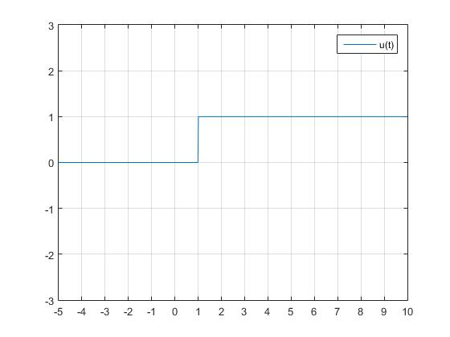

Code:

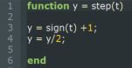

Since sign(x) function returns 1 when x is greater than 0, returns 0 when x is 0 and returns -1 when x is lesser than 0. Hence the Peak to Peak amplitude is 2. To get the step function we need to shift up the graph up 1, done using *line3*, which shifts the Peak to Peak to 2 to 0. After that, we need to reduce the amplitude from 2 to 1. This is where *line 4* comes in, which will reduce the amplitude from 2 to 1.

Exercise a, b & c in Experiment 5.1

Graph:

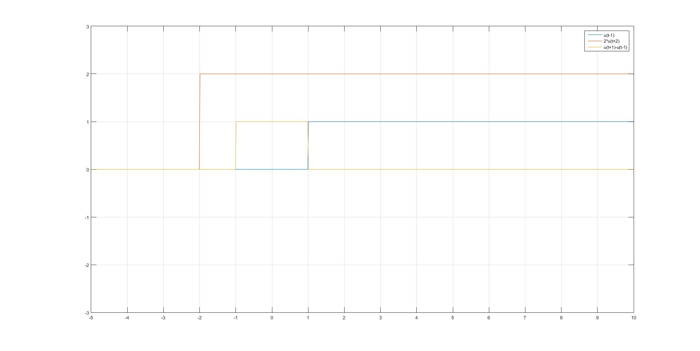

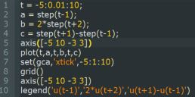Code:

First, the independent variable t need to be initialise. The range of t ranges from 5 to 10 and the sampling size is 0.01. This is achieved by *line 1*.

After that, the three equation need to be initialise which is u(t-1), 2*u(t+2) and u(t+1)-u(t-1) at *line 2,3 and 4* respectively